Target all terrorists, not just Islamic State, Turkey tells coalition
- THE AUSTRALIAN
- OCTOBER 09, 2014 12:00AM
- Print
- Save for later
24

Dennis Shanahan

Political Editor
Canberra
https://plus.google.com/103617325919509139218
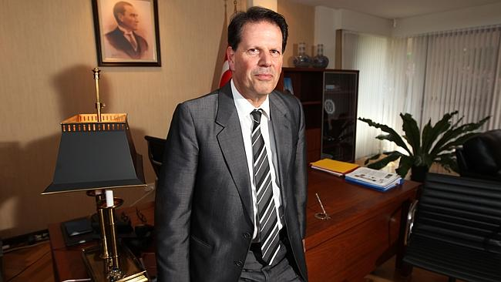
Turkey’s ambassador Reha Keskintepe. Picture: Gary Ramage Source: News Corp Australia
< Prev
Next >
•••
TURKEY has demanded that the US-led coalition in Iraq and Syria fight all terrorists equally, not just Islamic State, and called for help to deal with tens of thousands of refugees pouring across its border daily before taking greater military action.
Turkey’s ambassador to Australia, Reha Keksintepe, told The Australian yesterday his nation wanted the coalition forces to agree to three conditions as well as commit to fight all terrorist groups in Syria.
“It is very important that you don’t single out one organisation as terrorists and disregard the others, because in our view there are no good terrorists or bad terrorists,” Mr Keksintepe said in Canberra yesterday.
“There are terrorists, and they are recognised as such.’’
Turkish support is crucial for the fight against Islamic State because it can provide vital ground support to coalition airstrikes in Syria and Iraq, which Turkish President Recep Tayyip Erdogan said could not succeed on their own.
Mr Keksintepe said one of Turkey’s main concerns was another terrorist group, such as the Kurdish Workers Party, or PKK, being allowed to take over in the troubled region if the Islamic State terrorists were destroyed.
Turkey and the PKK have been fighting for decades and PKK fighters, including many women, are in the frontline against Islamic State fighters in Syria and Iraq.
Hundreds of Kurds took part in violent protests in several Turkish cities yesterday over Turkey’s lack of action in dealing with Islamic State extremists across the border.
As Australian combat air missions continue and 200 special forces troops prepare to “assist and advise” Iraqi ground troops against Islamic State terrorists in Iraq, Mr Keksintepe said Australia was doing its “fair share”.
Tony Abbott said yesterday Australia had a “very clear mission in Iraq and we’ve got a very clear mechanism for realising our mission in Iraq”.
“Our mission is to assist the Iraqis to disrupt and degrade the ISIL death cult,” the Prime Minister said.
Mr Abbott, like US President Barack Obama, has been wary of being drawn into a ground fight in either Iraq or Syria, where there has been a civil war for three years, and has called on Middle Eastern nations to help. “We shouldn’t try to do this on our own,” he said. “Our mission is to assist the Iraqi people to help themselves.”
Mr Erdogan and Turkish Prime Minister Ahmet Davutoglu have spoken more publicly about the fight in Syria and Iraq since the release of 49 Turkish hostages who had been held by terrorists, and after facing criticism from the US about not securing its borders or doing more in Syria against Islamic State.
Mr Davutoglu told CNN his country was prepared to do what was necessary but wanted a clear strategy from the US-led coalition.
“We are ready to do everything if there is a clear strategy that, after ISIS, we can be sure that our border will be protected,” he said. “We don’t want the regime anymore on our border pushing people against — towards — Turkey. We don’t want other terrorist organisations to be active there.
“We want this humanitarian policy on the other side of the border. Second: military strategy, security. If there is any threat against our national security, we will take all the measures, all the measures.”
The Turkish parliament has approved military action in Syria but Mr Erdogan has set three conditions to which the coalition forces must agree: a no-fly zone over Syria, a secure “safe haven” for the 1.5 million refugees from Syria and Iraq now in Turkey and a system of training and equipping moderate opposition forces in Syria.
Mr Keksintepe said Turkey also wanted to ensure its borders were safe if the Assad regime, which it opposes, fell and Islamic State was “destroyed and degraded”.
“You cannot pick and choose between terrorist organisations,” he said.
Mr Keksintepe said the Turkish strategy had a humanitarian component aimed at the huge number of refugees in Turkey and a military component to defend its borders.
“If Turkey’s borders are under threat, we will defend them,” he said. “There have been shells falling on Turkish territory and we have responded in kind, targeting where those shells came from.”
The ambassador said Turkey was being flooded with refugees from Syria and Iraq, with 180,000 arriving in just the past three days.
“The international community is not doing enough to assist Turkey, including international organisations, we are not complaining or criticising but we need more help,” he said.
“The dimensions of this catastrophe are difficult to imagine for people in Australia and Western countries, but you have to realise what it would be like if you had thousands and thousands of people arriving on your doorstep every day.”

